JavaScript Project

1. **Proposal Summary**
   1. **To create a visualization that compares the COVID-19 hospitalization rate and occupancy between California and Florida from March 1, 2020 to January 10, 2020. Each state took a dramatically different approach to handling COVID-19 multiple case spikes where California went on full lockdown, while Florida decided to open up to near pre-pandemic capacities.**
2. **Data Link and Data Set**
   1. [**https://healthdata.gov/dataset/covid-19-reported-patient-impact-and-hospital-capacity-facility**](https://healthdata.gov/dataset/covid-19-reported-patient-impact-and-hospital-capacity-facility)
   2. 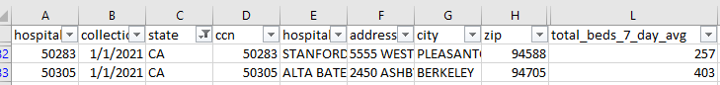**Data Set Snapshot**
3. **Data Visualization Inspirations**
   1. 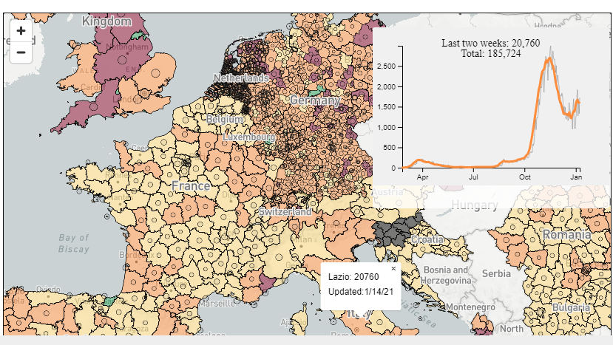[**https://www.endcoronavirus.org/europe**](https://www.endcoronavirus.org/europe)
   2. [**https://covidtracking.com/data/hospital-facilities#-91.0830067388062,37.54766805962086,3.5**](https://covidtracking.com/data/hospital-facilities#-91.0830067388062,37.54766805962086,3.5)